Introduction

Coastal Dynamics was approached by Eco Engineering to perform a survey in the Guayaguayare Bay where Plipdeco has proposed to build its port and alternative channel. The aim of the survey was to assess the spatial distribution of seagrass in the area. A survey done earlier in 2004 by the IMA showed that the Guayaguayare Bay has seagrass beds adjacent to the coastline, and part of the bed extended into the area for the proposed alternative channel for Plipdeco (see Figure 1 below). Coastal Dynamics personnel embarked on this survey on Wednesday 13th October 2004 to determine the extent of the seagrass coverage in the area within the proposed alternative channel.

INSERT FIGURE 1… WAITING ON NEAL…..
Methodology

Co-ordinates were chosen prior to going out into Guayaguayare Bay using Fugawi 3 – Moving map software for GPS receivers. These co-ordinates are shown in Table 1 below, and illustrated by Figure 2:

Table 1: Co-ordinates chosen for seagrass survey (NAP/BWI)
Station | Eastings | Northings
A | 718032 | 1121746
B | 718267 | 1121598
C | 718353 | 1121737
D | 718142 | 1121895

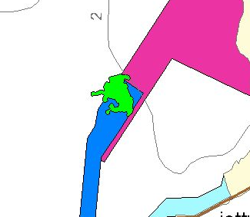

A

B

C
D

Figure 2: Area surveyed (in green) within co-ordinates chosen prior to seagrass survey (outlined in black)

On Wednesday 13th October 2004, the two divers, along with the rest of the survey team, reached the chosen area, a buoy was tied onto one of the divers. The divers entered the water together and swam around within the area, using two cameras – a Canon S50 digital camera, and an Olympus C8080 digital camera - to take photographs and short video clips of the area. To ensure the divers stayed within the chosen survey area, readings were taken using the Garmin Etrex GPS by another survey team member, who followed the divers at a safe distance in the boat.

Results

There was seagrass throughout the survey area with varying degrees of density. The seagrass, identified as Halodule wrightii, was found mainly in discontinuous patches a few metres apart on the seabed. These patches differed in size from clumps less than 1m² to over 10m² in area. At some locations, there were fairly dense areas of the seagrass, as seen in Figure 3 below:

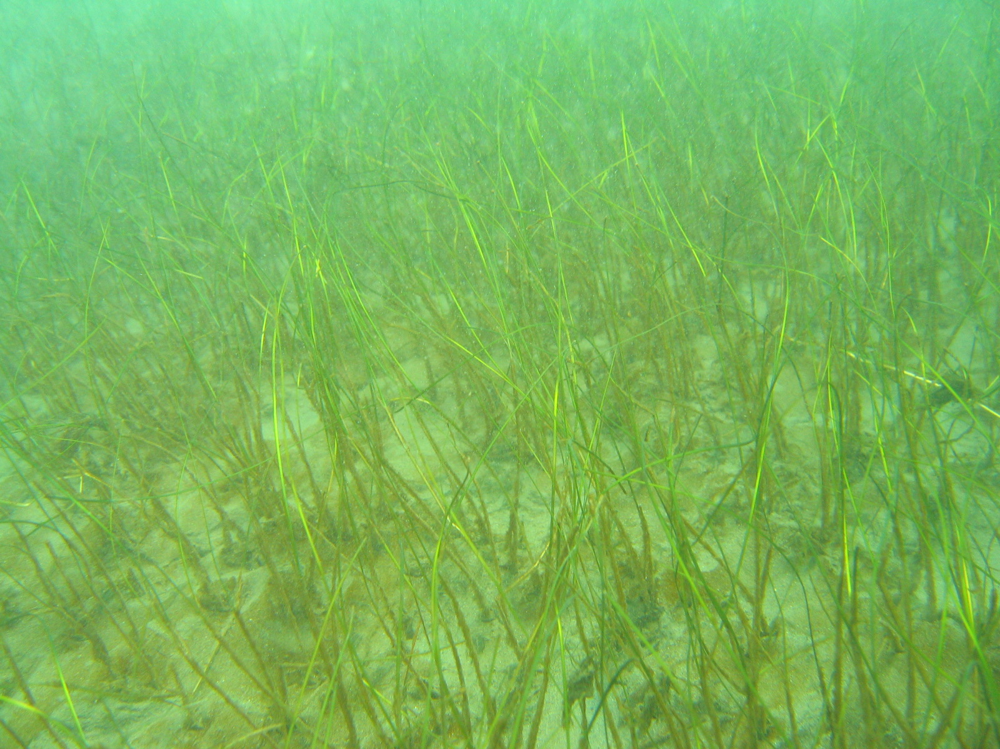

Figure 3: Fairly dense area of seagrass found within the proposed alternative channel

These dense areas of seagrass were found in the area indicated by the arrow on Figure 4 below:

Fairly dense area of seagrass found here

Figure 4: Location of fairly dense area of seagrass
Many locations showed less dense areas of seagrass where the sandy sea-bottom was very clearly visible, as seen in Figure 4 below:

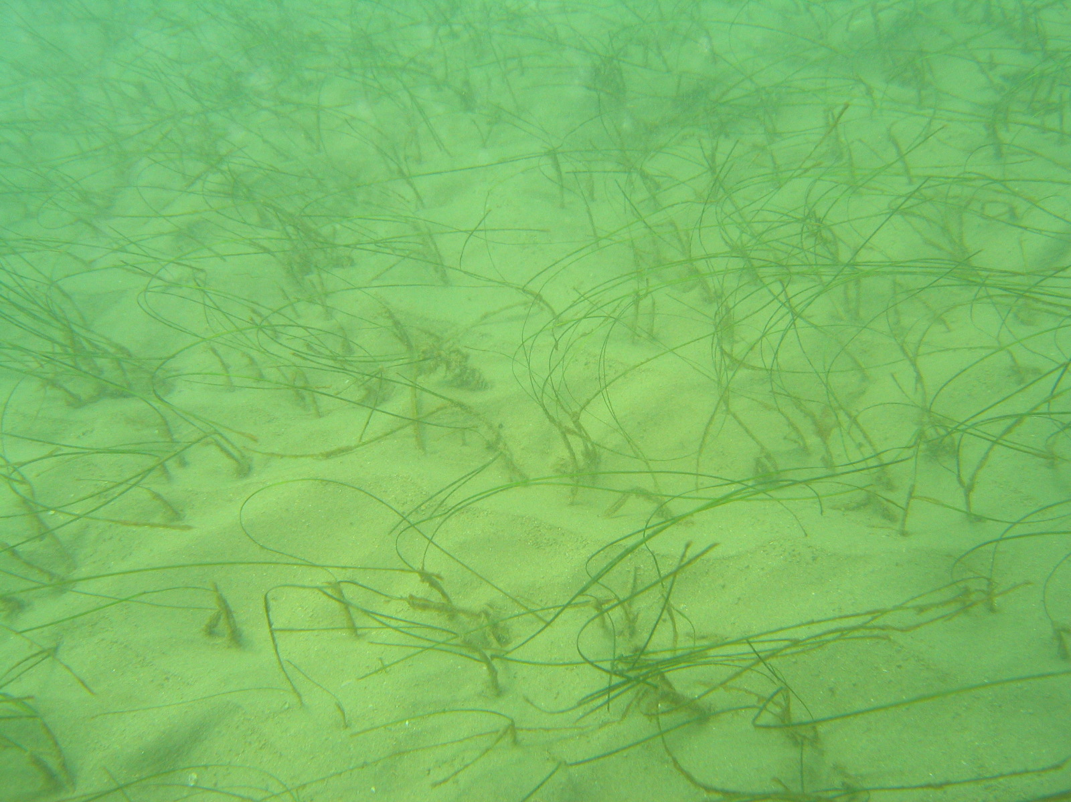

Figure 4: Less dense area of seagrass found within the proposed alternative channel

This picture was taken in the area indicated by the arrow in Figure 5 below:

Less dense area of seagrass found here

Figure 5: Location of less dense area of seagrass

In some cases, there were rings of seagrass, with greener, denser areas around the perimeter, but the inner part of the ring was mostly sandy (Figure 6).

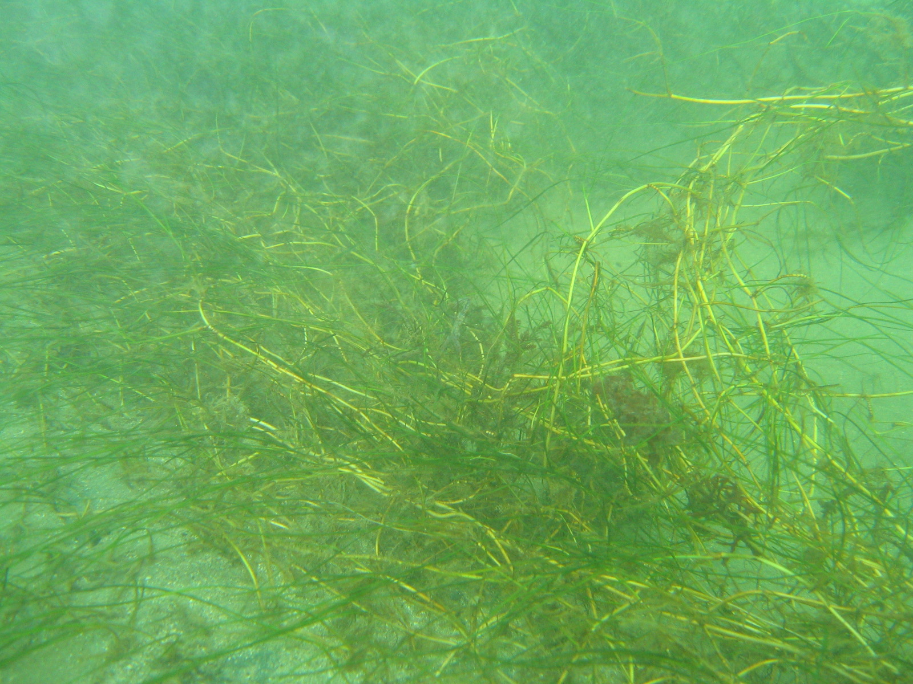

Figure 6: Part of a ring of seagrass showing a denser perimeter around a sandier interior (sandy area to the right of the photograph)

This may have indicated an area of disturbance, either due to strong currents or bad weather. Halodule wrightii, usually a pioneer species found under such situations of disturbance, is particularly proficient at adapting itself to oligotrophic conditions (conditions of low nutrient concentrations). Also, the seabed appears to be made of sandy hard-bottom. This also lends to less dense formations of the seagrass as well as an inability to support other species.

