SECTION 4

anaysis of alternatives
- Analysis of Alternatives

This section provides an evaluation of reasonable alternatives for project design options with a brief discussion of the pros and cons of those alternatives. In order to do this effectively an evaluation model was developed. This model looked initially at the social, environmental and economic impacts of each of the mentioned alternatives.

  - Background

The pipeline system was installed approximately 30 years ago and the pipeline has reached the end of its design life. Currently, loading pressures have been reduced to minimize the likelihood of environmental damage, thus driving the need for pipeline replacement.

  - ‘No Action’ Alternative

Under this scenario the existing 42” pipeline and 16” deballast line would remain active, despite being past its intended design life. The risks associated with this option are that pipeline failure, such as a small leak to line rupture is likely to occur at some point. This statement is supported by the identification of three sites where external corrosion was noted within the last two years. Additionally, two small leaks have occurred within the last two years. The environmental risk of continuing operations using the existing infrastructure is therefore greater than the line replacement activities. Additionally, the duration of the impacts of line replacement would be significantly shorter than the effects of a persistently leaking line. The immediate economic benefit (including primary and secondary benefits) to the community from the replacement of the line would not occur. Further, continuing operations as they are now would mean higher operating costs for bpTT, through continued reduced operating capacity and high maintenance costs. This in turn would reduce the resources available for the community development programme in the area for which bpTT has taken a prominent and leading role.

  - Route Selection Options

Route selection was based on onshore site location, shore approach method, single/dual line, onshore pipe, and line size selections.

    - Pipeline Landfall

As shown in Figure 4.1, seven options were identified for pipeline landfall.

Figure 4.1: Options for pipeline landfall
      - Base Case Option

The location of landfall in this option would be in the pipe storage lot next to the government building. Stored pipe would therefore need to be relocated. An open cut shore approach would obstruct the jetty road requiring it to be re-routed. There is also the possibility of a smaller “portable” buildings needing relocation. Existing 42” pipeline, de-ballasting pipeline, government building, jetty pylon and minimal shore access provide limited room for pipe corridor. There are also multiple pipe and electrical conduit crossing.

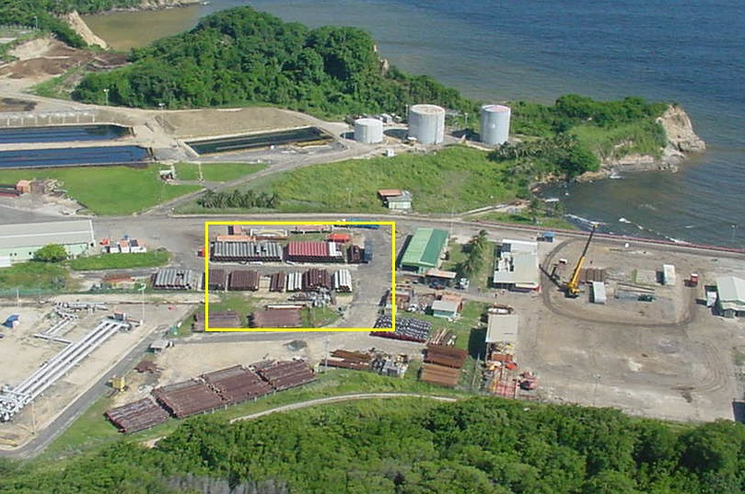

Figure 4.2: Landfall Location for Base Case Option

      - Option A

This option required the passage of the pipeline through the mangrove north of jetty area. This option would require that an area of mangrove for the passage of the pipeline be cleared. This option was excluded from further consideration as it would result in environmental damage through the fragmentation of the mangrove. Additionally regulatory approvals would be required (Forestry Department) for the felling of trees and the acquisition of land for right of way. Additionally, shore approach would block access road used by coast guard. Finally, this option would be inconsistent with bpTT’s Health, Safety, Security and Environment policy.
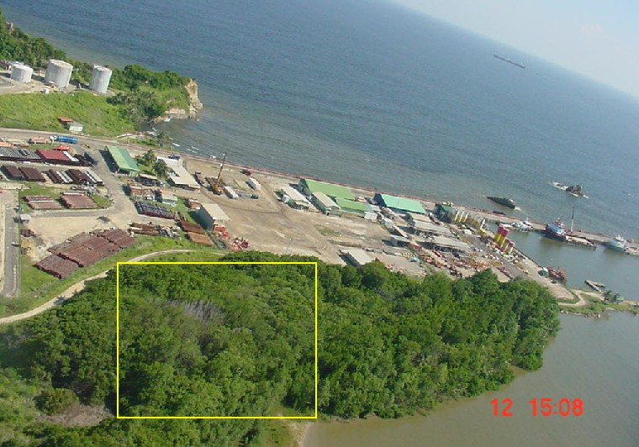

Figure 4.3: Landfall Location for Option A

      - Option B

This option required the pipeline to come ashore along the jetty. This option was deemed not feasible due to likely interference with day to day shipping traffic and plant operations along jetty. The shallow water depth prevents lay barge accessibility which would result in insufficient room for pull-in during pipe lay execution. Additionally, pipe racks along jetty would be required to facilitate this option. Multi-line and electrical conduit crossing would pose a significant and unacceptable health and safety risk to project execution team members. Lastly, the construction could affect structural integrity of jetty. It was thus excluded from further consideration.

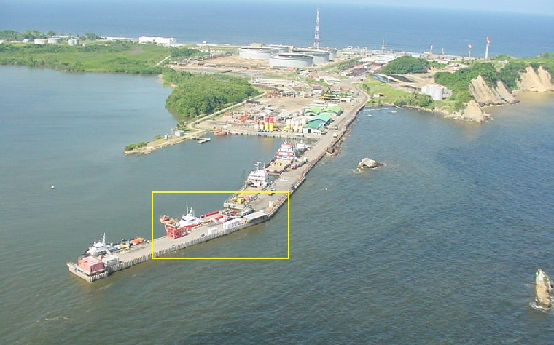

Figure 4.4: Landfall Location for Option B

      - Option C

This option required the pipeline to come ashore at Bio-Pad 1 where the 12” Cassia B condensate line was horizontally directionally drilled. This option would require the bio-remediation site and bio-matter would need to be temporarily relocated and the possibility of crossing the existing 12” condensate line.

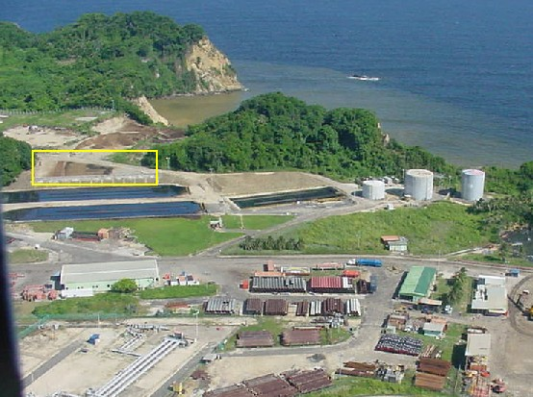

Figure 4.5: Landfall Location for Option C

Figure 4.6: Pipeline Landfall for Option C
      - Option D

The location of the line would be at the Halliburton lay down area for this option. This option was seen as not being feasible due to the lack of available work space and was excluded from further consideration. Additionally, for an open cut option, interference with day to day shipping traffic and plant operations along jetty is likely and shallow water depth prevents lay barge accessibility. For the HDD option the bore would be at a shallow depth at the Jetty crossing, increasing the risk of inadvertent returns of the drill mud.

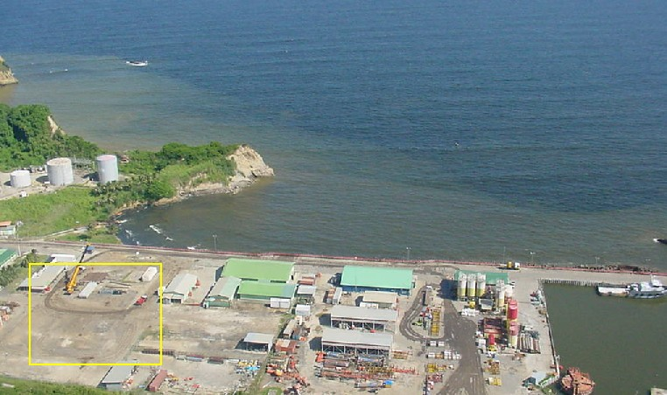

Figure 4.7: Landfall Location for Option D

      - Option E

This option requires the line locations to be south of settling and ballast ponds. This option required civil works to flatten a hill and remove earth. This would significantly affect the topography of the area.
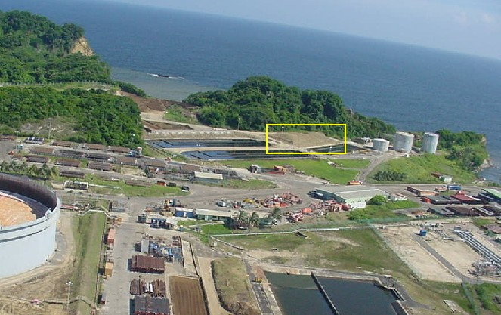

Figure 4.8: Landfall Location for Option E

Figure 4.9: Pipeline Landfall for Option E
      - Option F

For this option the pipeline location is in the compost area east of fire water training site. In order to facilitate the pipeline compost would need to be relocated. For this option there is the offshore crossing of existing 12” condensate line. This location was deemed to be the most suitable as does not have any significant environmental impacts and it provides the least interference between HDD process and day to day plant activity.

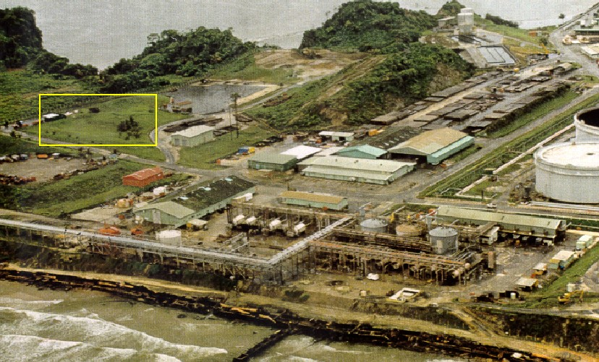

Figure 4.10: Landfall Location for Option F

Figure 4.11: Pipeline Landfall for Option F
    - Shore Approach Selection

The base case for shore approach was the traditional open cut option. During the option selection process, the environmental impacts of an open cut versus a HDD were considered. Open cut drilling involves dredging of the sea floor this would result in;
- The disturbance and loss of sensitive benthic communities.
- Changes in physiochemical parameters throughout the water column eg. increased turbidity
- Disturbance of nektonic marine species.
- Changes in bathymetry
Based on these factors it was determined that HDD was the environmentally impacting option. In addition, many of the route selection options precluded the ability to perform an open cut.

    - Single/Dual Line Selection

Along with a single line option, a dual line option was also considered for the added benefits of diver-less pigging.

    - Onshore Pipe Route Selection

Currently the integrity of the offshore pipeline is the limiting factor in the maximum operating. Assuming the offshore replacement, the limiting factor will shift to the onshore segment. Due to the lack of ability to hydrotest the onshore segment, without disruption of operations, the integrity of the onshore pipe is difficult to confirm for a 30 year life. Therefore, the new offshore pipeline was sized for options which reuse the onshore segment and for options where the onshore segment was replaced. Cases with replacement of the onshore section allows the integrity to be re-established and due to increased operating pressures, the use of smaller offshore pipe, reducing pipe material cost and risk associated this the HDD.

    - Line Size Options

Based on hydraulic analysis, the recommended offshore pipeline size for each scenario is as follows:
- 36” for a single line with existing onshore pipe
- 32” for a single line with new onshore pipe
- 28” for a dual line with existing onshore pipe
- 24” for a dual line with new onshore pipe
In the event a dual line selection, the corresponding single line size would be used for the onshore segment with a manifold at the launcher/receiver.

    - Change from 32” to 30” diameter pipe

After the evaluation of alternatives report was completed, additional technical data became available that supported the selection of 30” diameter pipe over 32” diameter pipe. 30” diameter pipe is a more standard diameter of pipe, thus reducing the time for procurement, cost of the pipe and associated supporting equipment (i.e. flanges, valves, etc.). This change in diameter would not have affected the selection of option F.

    - Route Options Matrix

      - Route Options

Table 4.1 identifies the route options. Note that some options have been excluded from further review based on the deciding factors listed in the previous section above. For the locations C, E and F an open cut shore approach was deemed not to be feasible, it was however feasible for the base case option.

Table 4.1: Route Selection Matrix

    - Ranking Criteria

An evaluation and comparison was made for each route option based on environmental, technical and cost criteria.

      - Environmental

Where applicable, consideration was given to the following onshore and offshore environmental concerns:
- Resulting algal/rock reef damage from the selected shore approach option
- Onshore and offshore geotechnical surveying
- The release of drill fluids from HDD
- Disposal of cuttings from trenching
- Sedimentation of cuttings on ocean bottom from trenching
- Onshore relocation of bio remediation site

      - Technical

The schematics above show the shore approach location and respective options for onshore pipe routing – utilization of existing pipe (with some new pipe), replace existing with new pipe, and reroute with new pipe. Note for the existing pipe option, the tie-in point between the new and the existing pipe is assumed at the tank farm dike. Where applicable, each option was ranked according technical criteria below.
- Length – overall length of new pipe section
- Crossings – non removable obstructions to construction (i.e. existing pipeline, pipe, conduit, roads, sheet pile)
- Operations Onshore - interference of day to day plant operations due to onshore pipe route construction.
- Operations On-Site – interference of day to day plant operations due to shore approach site
- Pigging Capability – considers benefit of a diverless pigging with the dual lines
- Shore Approach Method – construction complexity of shore approach method, with additional consideration to # of lines
- Shore Approach Location – obstructions at shore approach location site requiring removal (i.e. pipe in storage, compost, earth)
- Integrity Onshore – existing vs. new pipeline
- Integrity Offshore – single vs. dual pipeline

      - Cost

The values for cost come from initial values from estimating and incorporate both onshore and offshore pipeline only. The offshore route length for each option was virtually the same, therefore cost variation came from the onshore section.

      - Ranking Matrix

The criteria was ranked on a scale from one (minimal impact) to five (high impact) for each route option.

      - Un-Weighted Matrix

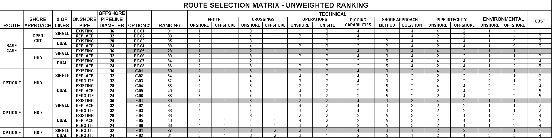
A summation of the criteria rankings was made per route option to identify the lowest un-weighted ranking total. This defined the most preferred route(s). Based on estimating, the option determined to have the highest cost was ranked at a five, with the remaining route option costs normalized accordingly.
Table 4.2: Route Selection Matrix – Unweighted

      - Weighted Matrix

Another table was created with a modified ranking. The modified ranking used a multiplier on select criteria from the un-weighted matrix. The percentage weights are as follows: Operations 10%, Pigging Capabilities 7%, Environmental 50%, and Cost 33%. The ranking from the Un-Weighted Matrix is included in this table for comparison.

Table 4.3: Route Selection Matrix – Weighted
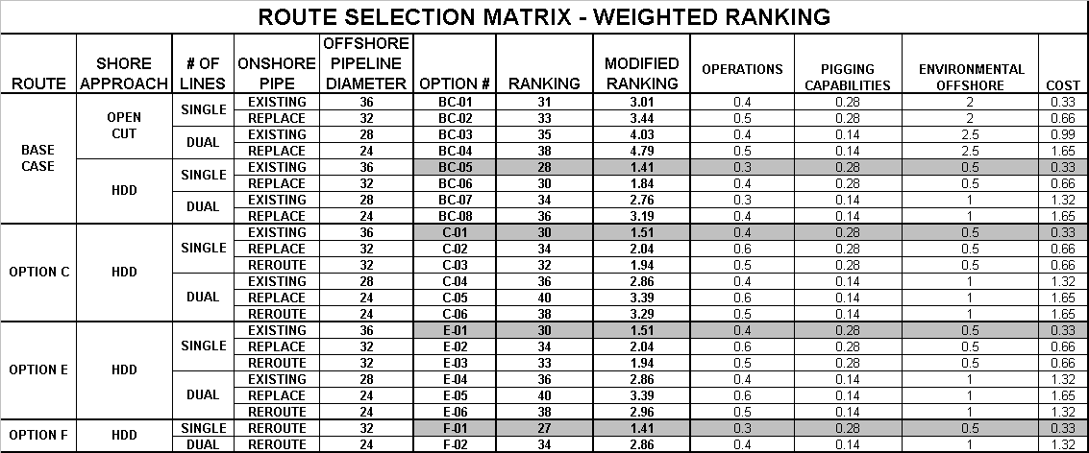
    - Recommendations & Conclusion

Both the Weighted and Un-Weighted Matrices are in agreement as to the best route option for each shore approach location. They are as follows:

Base Case Option #BC-05 / HDD / Single / Existing Onshore Pipe / 36”
Option C #C-01 / HDD / Single / Existing Onshore Pipe / 36”
Option E #E-01 / HDD / Single / Existing Onshore Pipe/ 36”
Option F #F-01 / HDD / Single / Reroute (New) Onshore Pipe / 32”

For the selected route options, HDD is shown as the preferred shore approach method. This can be attributed primarily to the high environmental impact which would result from an open cut shore approach. Cost was the most significant factor in selection of the single line over the dual. For the Base Case, C, and E Options, utilization of the existing onshore line is preferred over replacement or rerouting due to cost and operations impact. Note that new (reroute) onshore pipe was the only feasible choice for the shore approach location at Option F; however, it is still advantageous due to the short route length from the pump station to the shore approach site.

Utilizing existing onshore pipe leaves line integrity in question, thus requiring a larger offshore line size. The larger line size, in turn, increases the associated risk involved in a horizontal directional drill. Based on this logic, selection of new onshore pipe provides the best option in route selection.

An independent HDD consultant with Trenchless Engineering Corp, was brought in to review all shore approach locations. From his report, (ref DR-51-71-03), Option F was determined as the most feasible route. This reinforces the conclusion to the route selection methodology provided in this report.

    - Preferred Option – Route Selection

Option F-01, defined as a single 32-inch pipeline with new onshore pipe and a HDD shore approach, was determined as the preferred option for the NOEL Project. It provides a shore approach location in an area set apart from the facility, therefore minimizing interference with day to day plant activity. In addition, the onshore pipeline route from the pump station to the HDD site is short - providing a cost effective option which establishes the integrity of the onshore piping. Finally, the HDD method provides a positive environmental alternative for shore approach.
Further information became available subsequent to this analysis being conducted which indicated that the diameter of the line could be reduced further. The new design specification for the pipeline diameter is now a 30 inch as opposed to a 32 inch. This change in the diameter of the pipeline would not affect the selection of option F-01 over the other options.

  - Hydrostatic Testing

Hydrostatic pressure testing of the pipeline is a procedure where the pipeline is pressure filled with water for a period of time to ensure there are no leaks. The NOEL pipeline will actually include 4 separate hydrostatic tests. Approximately 1200 to 1700 meters of pipe to be used in the HDD will be assembled offshore from the lay barge. This string of pipe will be pressure tested before it is pulled through the HDD hole and then again after it has been pulled through the HDD hole. Finally, once the offshore pipeline has been connected to HDD tie-in point, then a final pressure test of the offshore system will occur. A separate pressure test for the onshore portion of the pipeline will be performed by the onshore pipe-lay contractor prior to the final “golden” weld connecting the offshore section to the onshore section. It is estimated that the four hydrostatic pressure tests will require a total of approximately 1 million gallons of seawater.

To eliminate bacterial growth and potential corrosion, it is standard industry practice to add treatment chemicals when seawater is introduced into the pipeline. The addition of treatment chemicals is not about corrosion during installation, but rather the introduction of contamination and long term integrity of the pipeline. If the bacteria find the conditions to form colonies in the pipeline during hydro-testing, they will also be active under normal service and continue to damage the pipeline long term. Once these colonies have settled on the steel service is very difficult to get rid of them.

The highest risk from the corrosion point of view is Microbially Induced Corrosion (MIC):
- Aerobic microbes thrive in presence of oxygen
- Anaerobic microbes thrive in the absence of oxygen

Oxygen scavenger will prevent growth of aerobic colonies and oxygen induced corrosion. The biocide will prevent growth of anaerobic colonies.

The NOEL Project Team considered the following options in selecting a hydrostatic testing strategy:

    - Option A: No Treatment Chemicals added

Hydro-test water would be discharged offshore from near the PLEM and subsea at the HDD tie-in point. Due to the duration of exposure for the pipeline to seawater and the long term pipeline integrity implications this option was seen as unfavorable.

    - Option B: Addition of Benign Treatment Chemicals

Hydrotest water would be discharged offshore from near the PLEM and subsea at the HDD tie-in point. These treatment chemicals are likely to be new to Trinidad and as such would not be on the approved list of chemicals. It is therefore likely that timely approval by the regulatory agencies may prove to be a significant challenge. Also the capability of the treatment chemicals to prevent MIC may not be as effective as proven treatment chemicals.

    - Option C: Conventional Treatment Chemicals Added

Hydrotest water would be discharged offshore from near the PLEM and subsea at the HDD tie-in point. Based on past modeling experience and nearshore location, is would be expected that there would be some impact from discharge. These previous models have indicated that the extent of this impact will be related to the volume of hydrotest water discharged.

    - Option D: Treatment Chemicals Added/ Neutralized offshore before discharge (PLEM & HDD Tie In)

Hydrotest water would be discharged offshore from PLEM and subsea at the HDD tie-in point. This option would require some sort of temporary tanks on the lay barge or other method of containing the treated water prior to discharge. Depending on the size of the tanks, there would be stand-by time for pipe-laying vessel spread while the treated water is being processed thus significantly increasing cost.

    - Preferred Option

In selecting an option for hydrotest water discharge consideration was given to the technical suitability of the method, long-term impact to environment, potential for creating delays and cost. A weighting for each of these considerations was developed and applied to each of the options. The weighting schemes ranged from 1 – Most Favorable to 5 –Least Favorable. The weightings were summed for each option and the option with the overall lowest value was deemed to be the most favorable. The results of this analysis are presented in Table 4.5 below.

Table 4.5: Hydrostatic Pressure Testing

Option | A | B | C | D
Technical Suitability | 5 | 2 | 1 | 1
Environmental Impact | * | * | * | *
Potential Production Impact | 1 | 1 | 1 | 3
Cost | 1 | 3 | 2 | 3
Total | 7 | 6 | 4 | 6

The environmental impact cannot be determined until the selection of the offshore pipe-lay contractor and HDD subcontractor, at which time the final location of the HDD point will be determined (between 1200 and 1700 meters out from shore and depth of water from 10 to 15 meters). For all occurrences where the duration of seawater in the pipe segments will be longer than 30 days, treatment chemicals will be added. Provisions will be made to neutralize these treatment chemicals prior to the discharge back to the sea. Detailed modeling plans for hydrostatic discharges are submitted within Volume 2, Appenidx IV.

The pipelay contractor will be demobilized prior to the start of commissioning, therefore will not be available for bringing water to surface. As a contingency, the commissioning activities have been designed to utilize existing 16” line to transport the treated hydrostatic test water from the final hydrotest of the new 30” line to the Galeota Terminal deballast ponds 4 and 5 for neutralization, aeration monitoring and discharge to sea. Deballast ponds 4 and 5 have a capacity of 3.5 million gallons. It is estimated that volume of treated hydrotest water will be less than 700,000 gallons.

  - HDD Execution – Transition Zone and Drilling Fluids

A typical HDD requires a transition area to provide a suitable radius of curvature between the drill exit point and the position of the pipeline on the seabed. This is generally achieved by dredging an exit pit on the sea bottom floor. Based on technical requirements not having an exit pit would add increased risk to installation and stabilization of pipeline as well as lack of containment for drilling fluids. Further the footprint left by dredging would not significantly affect the gross bathymetry of the bay.

Approximately 1800 m³ of solids (slurry mixture will be composed of 5% solids and 95% liquids plus pipeline bore material) will be returned to the subsea side of the HDD. These drilling fluids are non-toxic benign materials which are denser than seawater so will remain close to seabed floor unless impacted by current. This will minimize the environmental impact of the muds and greatly reduce its migration.

The NOEL Project evaluated the following alternatives for containing the drilling fluids at a water depth exit of approximately 10m to 14m:

    - Option A: Optimize pit size for collection of drilling fluids/ no backfill

In this option the drilling fluids would be left on the seabed floor and contained in a dredged pit sized to contain all of the fluid. This option will however create a significant dredge area required to ensure containment of all drilling fluid. Over time the solids in the drilling fluid will settle to the bottom of the pit thus leaving a large footprint on the sea floor. The dredge spoil material would be disposed of elsewhere.

    - Option B: Optimize pit size for collection of drilling fluids/ backfill

In this option the drilling fluids will be left on the seabed floor contained and in a dredged pit sized to contain all of the fluid. This option will however create a significant dredge area required to ensure containment of all drilling fluid. The dredge spoil material could be stockpiled and used as backfill for pit but some loss of dredge spoil material do to current activity is likely. In addition the backfill process is likely to displace the more flowing drilling fluids.

    - Option C: Minimize Pit Size/ Allow excess drilling fluids to settle on sea floor/ no backfill

In this option the drilling fluids would be left on the seabed floor and contained in a dredged pit sized to optimize the angle of exit required for the pipeline to return to the seabed floor. In this option the dredge area would be minimized, but would result in some loss of drilling fluid. Over time the solids in the drilling fluid will settle to the bottom of the pit thus leaving a small footprint on the sea floor. The dredge spoil material would be disposed of elsewhere.

    - Option D: Minimize Pit Size/ Allow excess drilling fluids to settle on sea floor/ backfill

In this option the drilling fluids would be left on the seabed floor and contained in a dredged pit sized to optimize the angle of exit required for the pipeline to return to the seabed floor. In this option the dredge area would be minimized, but would result in some loss of drilling fluid. The dredge spoil material could be stockpiled and used as backfill for pit but some loss of dredge spoil material due to current activity is likely. In addition the backfill process is likely to displace more flowing drilling fluids.

    - Option E: Minimize Pit Size/ Use casing to collect drilling fluids/ backfill(Collected in Barge, offshore disposal)

For this option the casings will be installed to bring drilling fluids to the surface where it will be collected in a barge and discharged at another location or disposed of on land. The dredge spoil material will be stockpiled and used as backfill for the pit. The use of a casing does not guarantee that this procedure would be effective at given water depth (45 ft), diameter of required casing (>42 ins), length of casing required to achieve the 12º angle to the surface, and potential head pressure from the muds in the casing.

    - Option F: Minimize Pit Size/ Use Vacuum Pump to collect excess drilling fluids/ backfill

The size of the pit to accommodate the exit angle will be minimized and a vacuum pump used to bring the fluids to the surface. The fluids will be collected in a barge and discharged at another location. The dredge spoil material will be stockpiled and used as backfill for the pit. This option will result in a smaller dredge area and will significantly reduce sediment loss. However, based on discussions with HDD contractors the attempt to recover drilling fluids proves to be expensive, time consuming and ineffective. Visibility will be low and distinguishing the drill fluid from the natural seabed floor will be very difficult. Additionally the turbidity in the surf zone will make visual identification of the drill mud impractical. Due to visibility, extraction would be ineffective during nighttime operations. This option also increases the amount of equipment and number of vessels required in an already congested offshore lay area and increases diver exposure.

    - Preferred Option

In selecting an option for HDD Execution – Drill Fluid Disposal consideration was given to the technical suitability of the method including additional complexity to vessel spread and potential for dive support, water quality impact due to sediment loading from drilling fluids, creation of a lasting footprint from dredged pit, and cost of equipment, vessel time and disposal costs. A weighting for each of these considerations was developed and applied to each of the options. The weighting schemes ranged from 1 – Most Favorable to 5 –Least Favorable. The weightings were summed for each option and the option with the overall lowest value was deemed to be the most favorable. The results of this analysis are presented in Table 4.7 below.
Table 4.7: HDD Execution – Drill Fluid Disposal

Option | A | B | C | D | E | F
Technical Suitability | 3 | 3 | 1 | 1 | 5 | 4
Water Quality Impact | 1 | 3 | 2 | 3 | 1 | 1
Footprint | 5 | 1 | 4 | 1 | 1 | 1
Cost | 2 | 3 | 1 | 3 | 5 | 4
Total | 11 | 10 | 8 | 8 | 12 | 10

Based on the evaluation Option C and D (Minimize Pit Size/ Allow excess drilling fluids to settle on sea floor/ and backfill the pit) appear to be the best available options for the disposal of drilling fluids. Option D was selected as the best available option as this option will result in minimal environmental impact from the drilling fluids as the prevailing current patterns are 10 knots westward and as such will transport the plume into the Columbus channel. The impact of the drilling fluids should be transient and temporary in nature. And Option D allows for backfilling of the exit pit thus minimizing the imprint on the seabed floor.

  - Decommissioning the Existing 42” and 16” pipelines

Alternatives evaluated for decommissioning of the existing 42” loading pipeline and 16” deballast pipeline have included complete removal of the pipelines or leaving pipelines in place. Removal of the existing pipelines offshore has been determined to be impractical, given the potential for leaving a physical footprint of impact on the seabed, and the increased safety risk exposure for workers and divers. Environmental baseline data gathered for this EIA has shown that the pipelines have become part of the natural ecosystem. Additionally, the natural process of footprint adjustment is likely to affect the wave and current patterns in the bay. The pipeline will be flushed of hydrocarbons to TTS547:1998 prior to mothballing the system, therefore there will be minimal risk of hydrocarbon leaks. Therefore, the preferred option is to mothball the pipelines in place in their offshore location.

  - Summary

The analysis of alternatives was conducted with a view to finding the best available options for the execution of technical requirements of the project. This exercise has indicated:
- The pipeline should be routed through the compost area east of fire training site utilizing 30” diameter pipe and a HDD for the shore approach
- Pending final installation design and approval from the EMA of the detailed hydrotest plan, any treated hydro-test water will be neutralized prior to discharge.
- A transition zone a pit should be dredged
- Drill fluid should be allowed to settle in place on the seabed floor
- The existing lines should be flushed, capped and mothballed in place

