Complete
Life Cycle Enhancement Approach

Sustainability fisheries
Stewardship
Corridor
- Target Species
1. Scomberomorus brasiliensis - Spanish mackerel
2. Caranx crysos – Blue runner
3. Caranx latus – Horse-eye Jack
4. Lutjanus purpureus - Southern red snapper
5. Macrodon ancylodon – King weakfish
6. Micropogonias furnieri – White-mouth croaker
7. Haemulon album - White margate
8. Epinephelus flavolimbatus – Yellow-edge Grouper
9. Sphyraena guachancho - Guachanche barracuda
10. Seriola rivoliana – Almaco (Amber) Jack

- Life cycle – habitat requirements
Spawning style
Spawning habitat
Larval stage – time and distance
Settlement requirement and habitat
Nursery habitat
Age of sexual maturity
Mature fish habitat

- Food
Larval stage diet
Nursery area diet
Mature fish diet

Increasing the percentage of properly designed hard substrate area, as well as the preferred refuge habitat, along with increasing the availability of foods required throughout their life cycle will have a direct and positive effect on the abundance of desired target fish species occurring within the area.

Scomberomorus brasiliensis
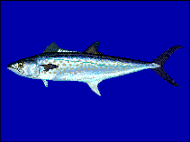

Spanish Mackerel
- Life cycle – habitat requirements
Spawning style - substratum egg scatterers
Spawning habitat - open water - year round but some peak times

Larval stage (time/distance)
Settlement requirement and habitat
Nursery habitat

Age of sexual maturity
Mature fish habitat
- Food
Larval stage diet -
Nursery area diet -
Mature fish diet - Feeds largely on fishes, with smaller quantities of
penaeid shrimps and loliginid cephalopods.

- Adult harvesting method - Demersal gillnet, banking lines, demersal long-line.
- Enhancement approach
Mature fish – Increase amount of baitfish in the area

Nursery area -

Notes: seasonal movement reported to occur off Trinidad.

Caranx crysos

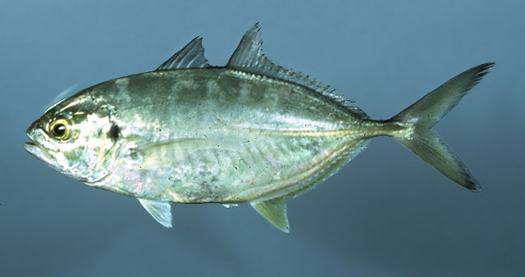

Blue Runner
- Life cycle – habitat requirements
Spawning style - Spawns offshore from January through August
Spawning habitat -

Larval stage (time/distance)
Settlement requirement and habitat
Nursery habitat

Age of sexual maturity
Mature fish habitat
- Food
Larval stage diet - Plankton
Nursery area diet - recruits/juvenile eat copepods
Mature fish diet - Feeds on fishes, shrimps and other invertebrates.

- Adult harvesting method –

- Enhancement approach

Mature fish – Increase amount of baitfish in the area

Nursery area -

Notes: A schooling species generally not far from the coast. Juveniles often found in association with floating Sargassum

Caranx latus
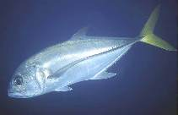
Horse-eye Jack
- Life cycle – habitat requirements
Spawning style -
Spawning habitat -

Larval stage (time/distance)
Settlement requirement and habitat
Nursery habitat

Age of sexual maturity
Mature fish habitat
- Food
Larval stage diet -
Nursery area diet –
Mature fish diet -

- Adult harvesting method –

- Enhancement approach

Mature fish – Increase amount of baitfish in the area

Nursery area -

Notes:

Lutjanus purpureus
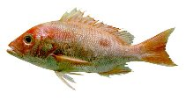
Red snapper
- Life cycle – habitat requirements
Spawning style -
Spawning habitat -

Larval stage (time/distance)
Settlement requirement and habitat
Nursery habitat

Age of sexual maturity
Mature fish habitat
- Food
Larval stage diet -
Nursery area diet –
Mature fish diet -

- Adult harvesting method –

- Enhancement approach

Mature fish – Increase amount of baitfish in the area

Nursery area -

Notes:

Macrodon ancylodon
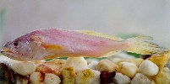
King Weakfish

- Life cycle – habitat requirements
Spawning style -
Spawning habitat -

Larval stage (time/distance)
Settlement requirement and habitat
Nursery habitat

Age of sexual maturity
Mature fish habitat
- Food
Larval stage diet -
Nursery area diet –
Mature fish diet -

- Adult harvesting method –

- Enhancement approach

Mature fish – Increase amount of baitfish in the area

Nursery area -

Notes:

Micropogonias furnieri
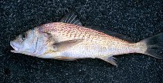
White-mouth croaker

- Life cycle – habitat requirements
Spawning style -
Spawning habitat -

Larval stage (time/distance)
Settlement requirement and habitat
Nursery habitat

Age of sexual maturity
Mature fish habitat
- Food
Larval stage diet -
Nursery area diet –
Mature fish diet -

- Adult harvesting method –

- Enhancement approach

Mature fish – Increase amount of baitfish in the area

Nursery area -

Notes:

Haemulon album
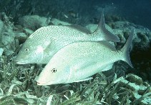
White margate

- Life cycle – habitat requirements
Spawning style – While spawning has not been observed it is believed spawning probably parallels that of other roving benthic predators such as snappers and groupers: that is migration to selected spawning sties on the outer reef and spawning is probably a group activity that occurs at dusk.
Spawning habitat – outer reef

Larval stage (time/distance) - approximately 15 days
Settlement requirement and habitat
Nursery habitat – Larvae settle to the bottom as benthic post-larvae at approximately 6 mm size. Juveniles are commonly found in small groups on grass flats, near mangroves and in other inshore areas

Age of sexual maturity – Reached at 37.5 cm size
Mature fish habitat - Inhabits seagrass beds, sand flats, coral reefs, and wrecks. Found in pairs or larger schools
- Food
Larval stage diet -
Nursery area diet – Benthic invertebrates, very similar diet as adults
Mature fish diet - Feeds on benthic invertebrates. Has been observed to nose into the sand to eat such subsurface invertebrates as peanut worms and heart urchins

- Adult harvesting method –

- Enhancement approach

Mature fish –

Nursery area -

Notes: Inhabits seagrass beds, sand flats, coral reefs, and wrecks (Ref. 9710). Found in pairs or larger schools (Ref. 3798).

Epinephelus flavolimbatus
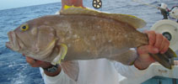
Yellow-edge grouper

- Life cycle – habitat requirements
Spawning style – Pelagic
Spawning habitat – Spawning by “groupers” takes place at localized “spawning grounds”. These spawning grounds are usually located above a seaward slope of a small reef separated by a narrow sand bank from surrounding reef on the edge deep water. Another requirement is places for the migrating fish to hide during the day

Larval stage (time/distance) The planktonic larval stage of all Epinephelus (grouper) is roughly 30 to 40 days
Settlement requirement and habitat
Nursery habitat – Juveniles are extremely secretive and thus require lots of hiding places (i.e. under rocks or among corals) and more often seen in shallow water.

Age of sexual maturity
Mature fish habitat
- Food
Larval stage diet -
Nursery area diet –
Mature fish diet -

- Adult harvesting method –

- Enhancement approach

Mature fish –

Nursery area -

Notes: A solitary species (Ref. 26340) occurring in rocky areas and on sand mud bottom. On soft bottoms they are often seen in or near trenches or burrow-like excavations. Feeds on a wide variety of invertebrates (mainly brachyuran crabs) and fishes.

Sphyraena guachancho

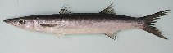
Guachanche barracuda

- Life cycle – habitat requirements
Spawning style -
Spawning habitat -

Larval stage (time/distance)
Settlement requirement and habitat
Nursery habitat

Age of sexual maturity
Mature fish habitat
- Food
Larval stage diet -
Nursery area diet –
Mature fish diet -

- Adult harvesting method –

- Enhancement approach

Mature fish – Increase amount of baitfish in the area

Nursery area -

Notes:

Seriola rivoliana
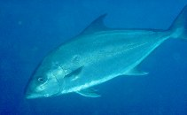
Almaco (Amber) jack
- Life cycle – habitat requirements
Spawning style -
Spawning habitat -

Larval stage (time/distance)
Settlement requirement and habitat
Nursery habitat

Age of sexual maturity
Mature fish habitat
- Food
Larval stage diet -
Nursery area diet –
Mature fish diet -

- Adult harvesting method –

- Enhancement approach

Mature fish – Increase amount of baitfish in the area

Nursery area -

Notes: Inhabits outer reef slopes and offshore banks to 160 m or more. Forms small groups (Ref. 26235). Adults are pelagic and demersal (Ref. 9283). Young often seen around floating objects (Ref. 4887, 48635). Feeds mainly on fishes, but also on invertebrates.

